LAB EXPERIMENT OUTPUTs
OUTPUT 1
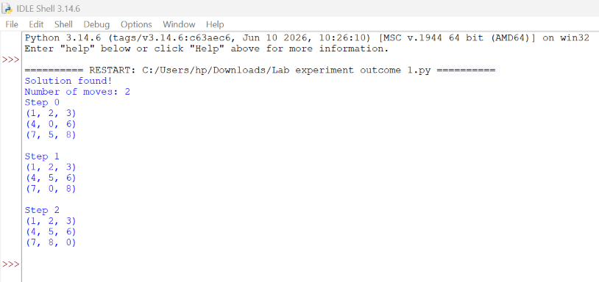

OUTPUT 2
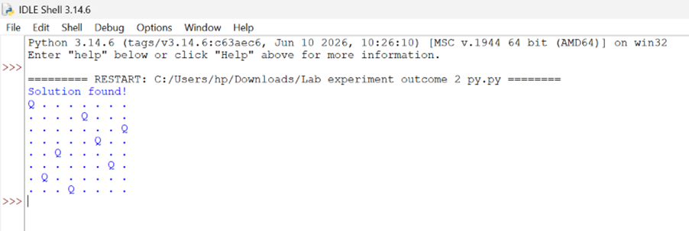

OUTPUT 3 OUTPUT 4
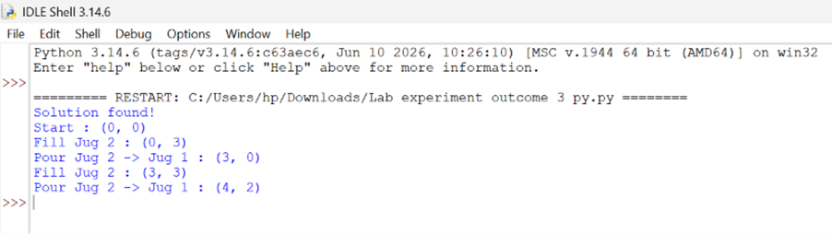
OUTPUT 4
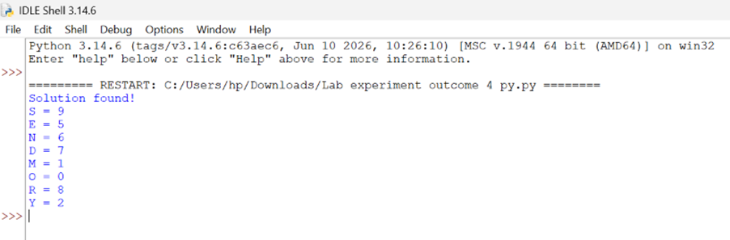

OUTPUT 5
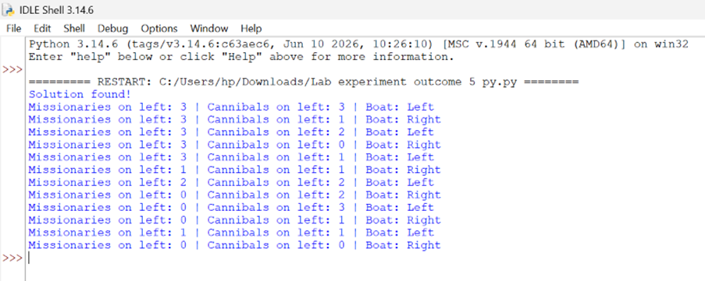

OUTPUT 6
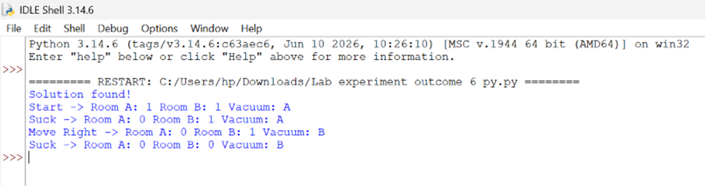

OUTPUT 7
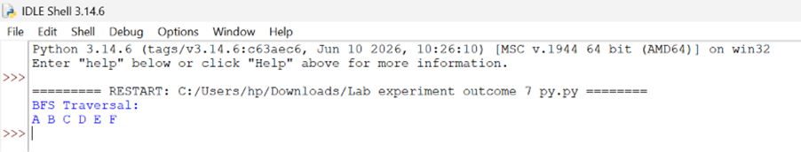

OUTPUT 8
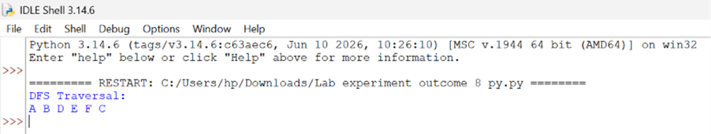

OUTPUT 9
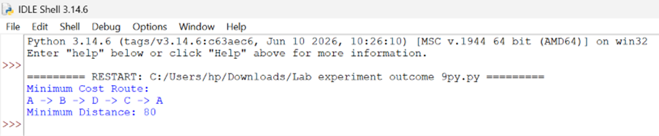

OUTPUT 10
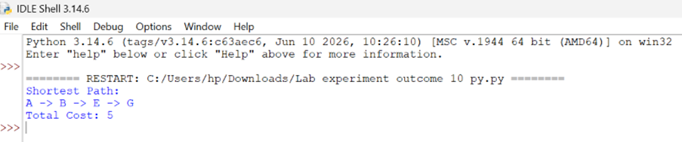

OUTPUT 11
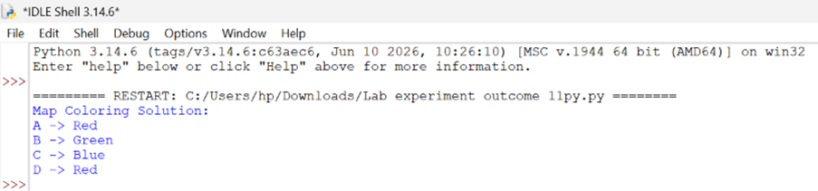

OUTPUT 12
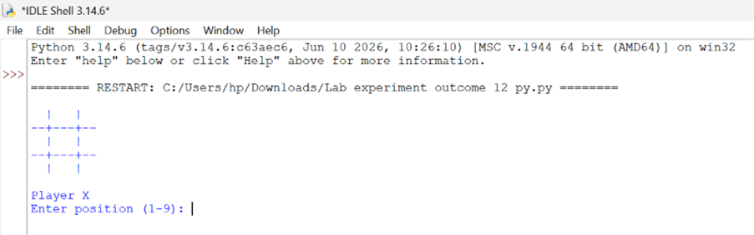

OUTPUT 13
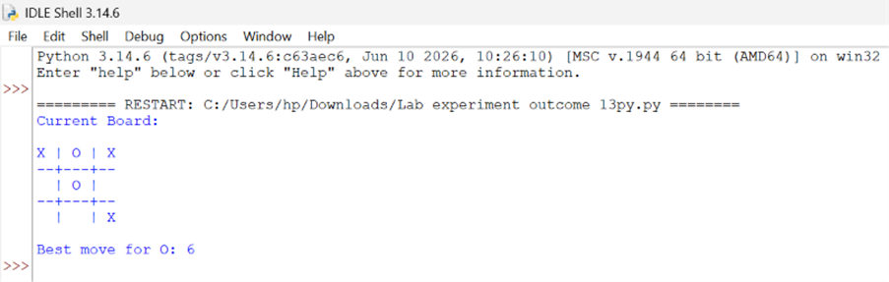

OUTPUT 14
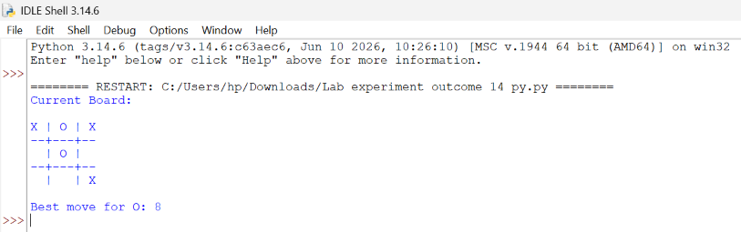
OUTPUT 15
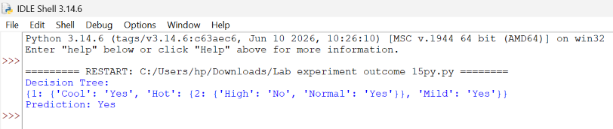

OUTPUT 16
